YAZHINI S

ASSESSMENT-1 (13-12-2023)

QUESTION -1

1. Querying Data by Using Joins and Subqueries.

🡪 I have created two tables in the names of customer1, supplier with its attributes.

🡪I have inserted values to the attributes.

🡪Finally, I have used inner join, left join, right join with both the tables customer1 and supplier.

TABLE-1 (customer1)

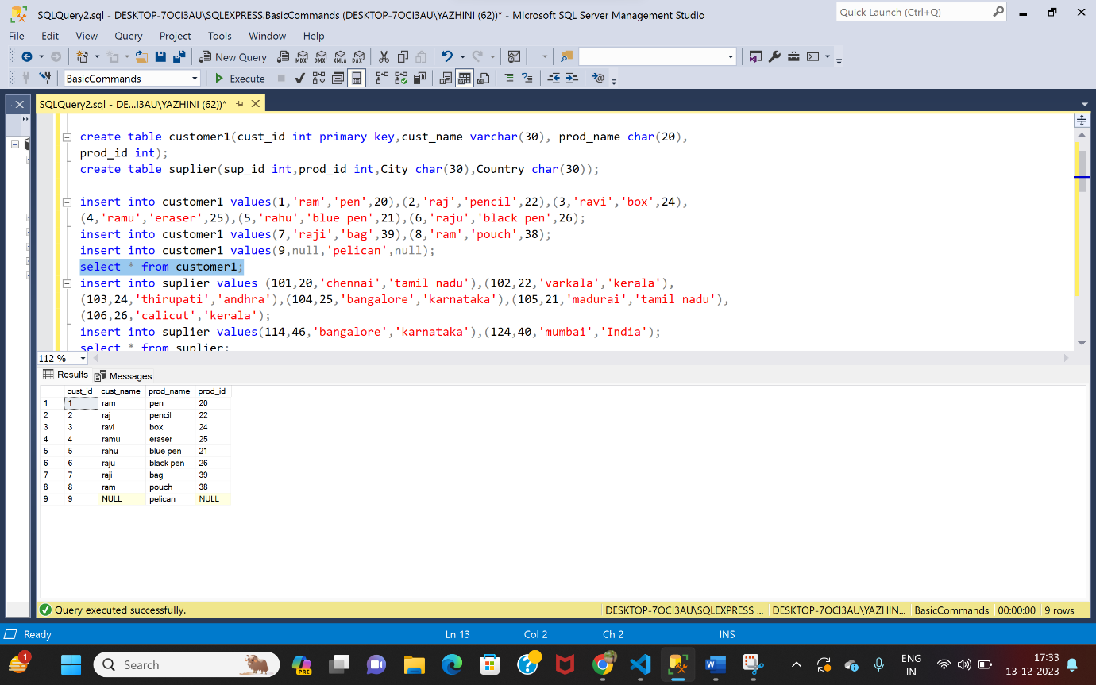

TABLE-2 (supplier)

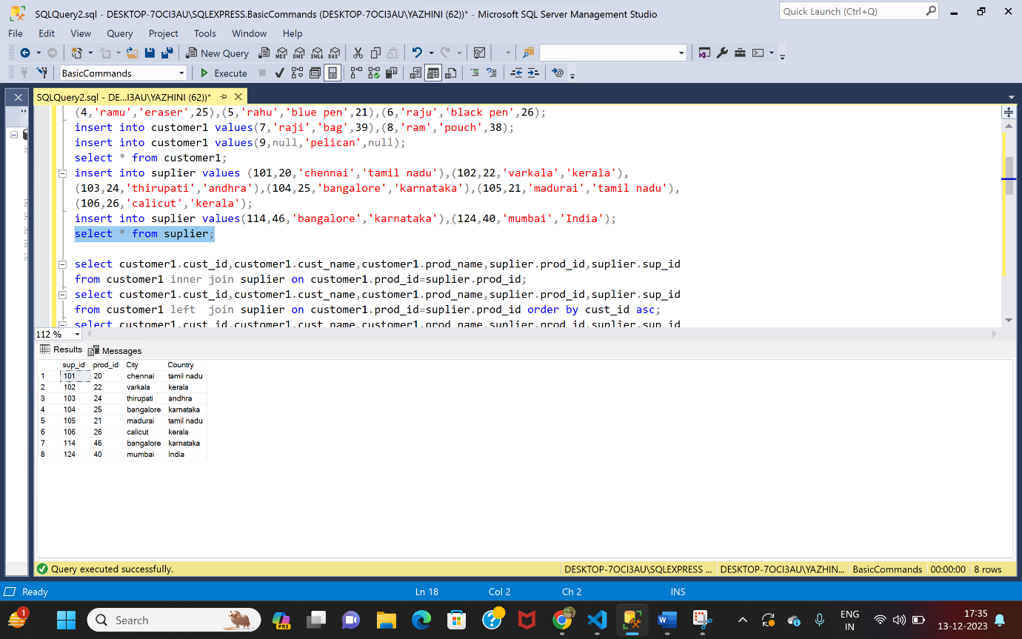

1)INNER JOIN

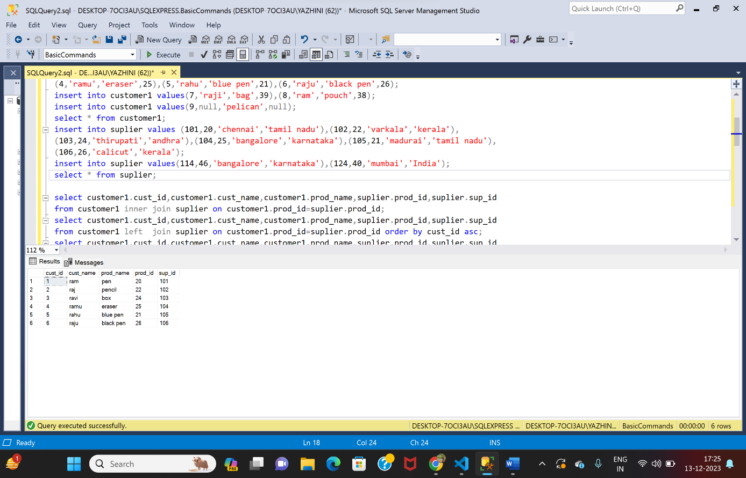

2)LEFT JOIN

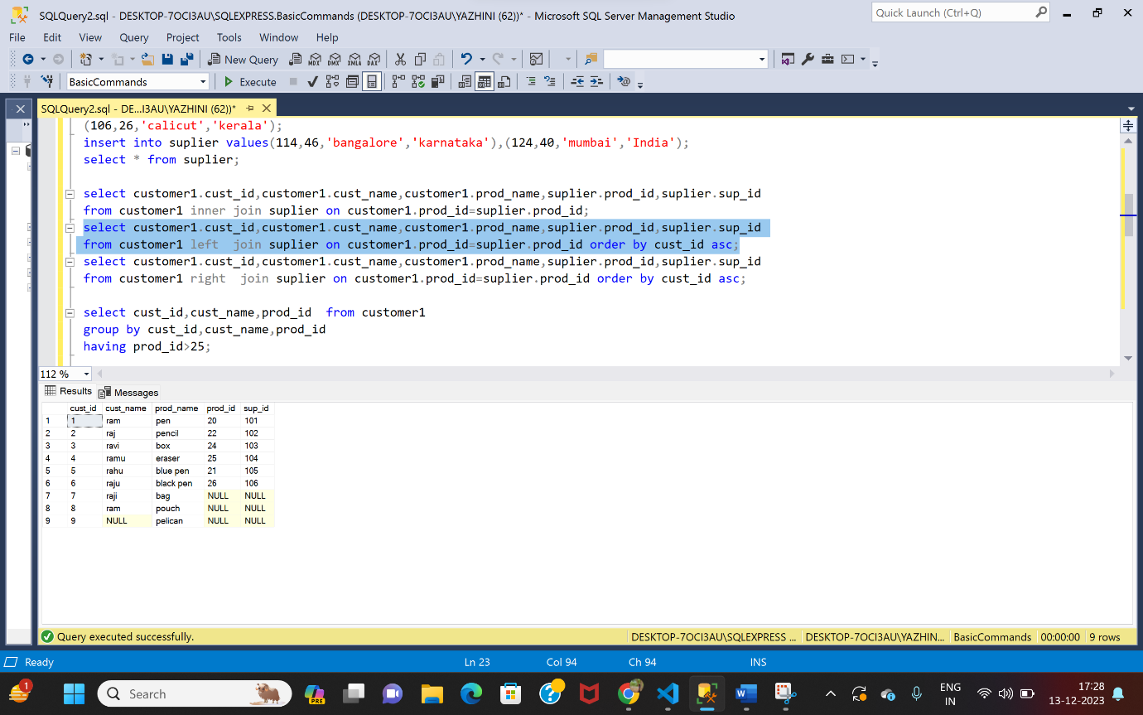

3)RIGHT JOIN

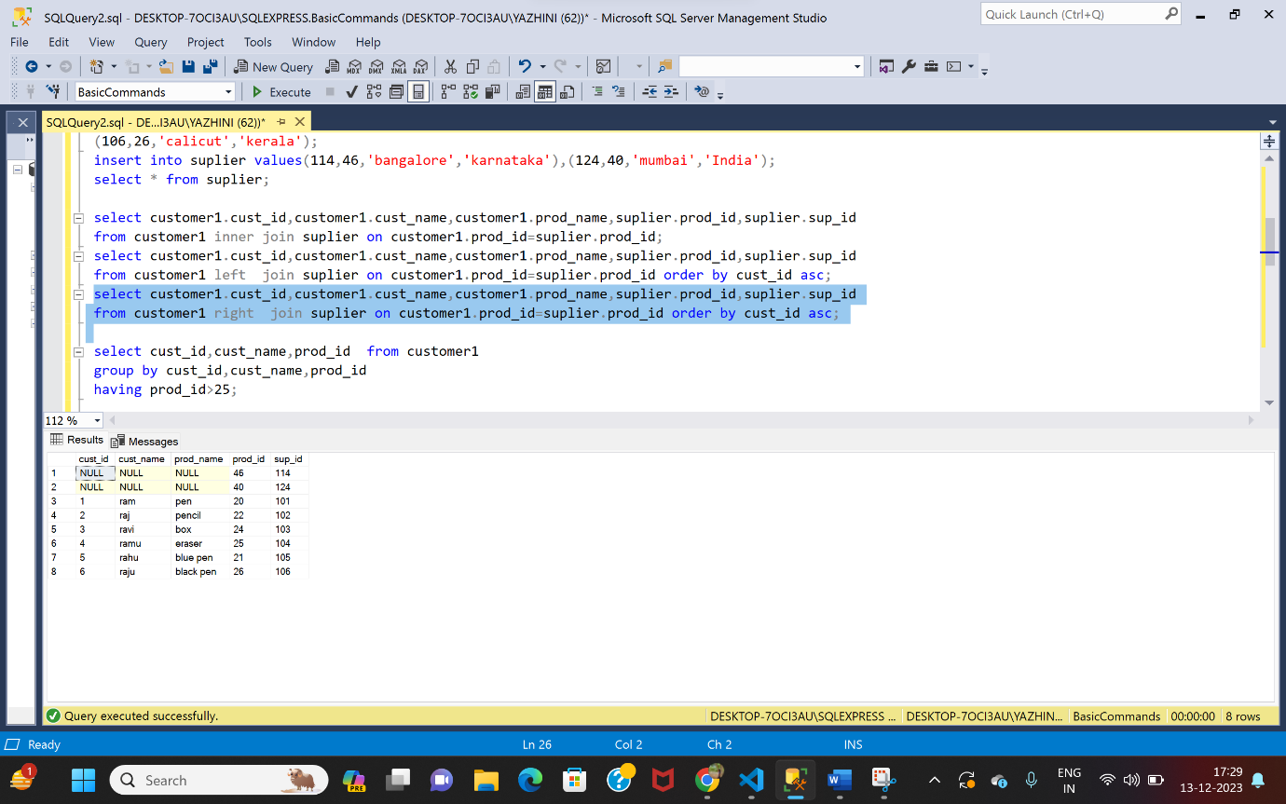

SUB-QUERIES

ORDER BY

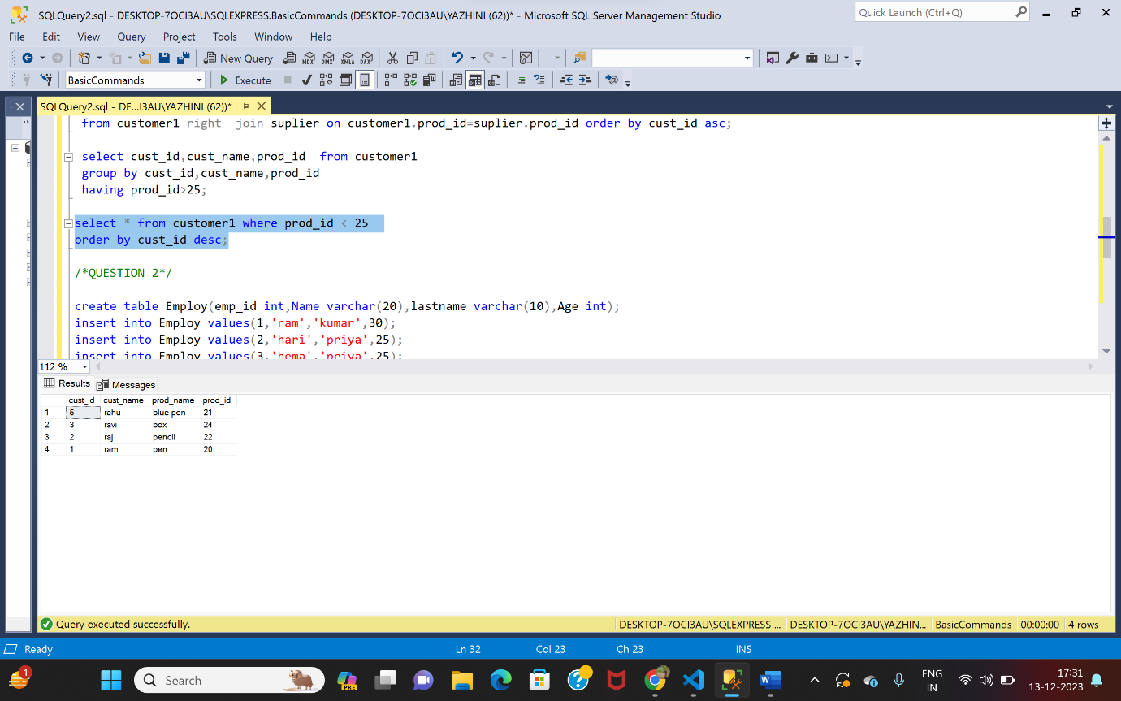

QUESTION-2

1. Manipulate data by using sql commands using groupby and having clause.

🡪I have created a table Employ with its attributes

🡪The manipulating commands that I used are

* Select
* Insert
* Update
* Delete

🡪Finally, I have used group by and having clause.

TABLE (Employee)

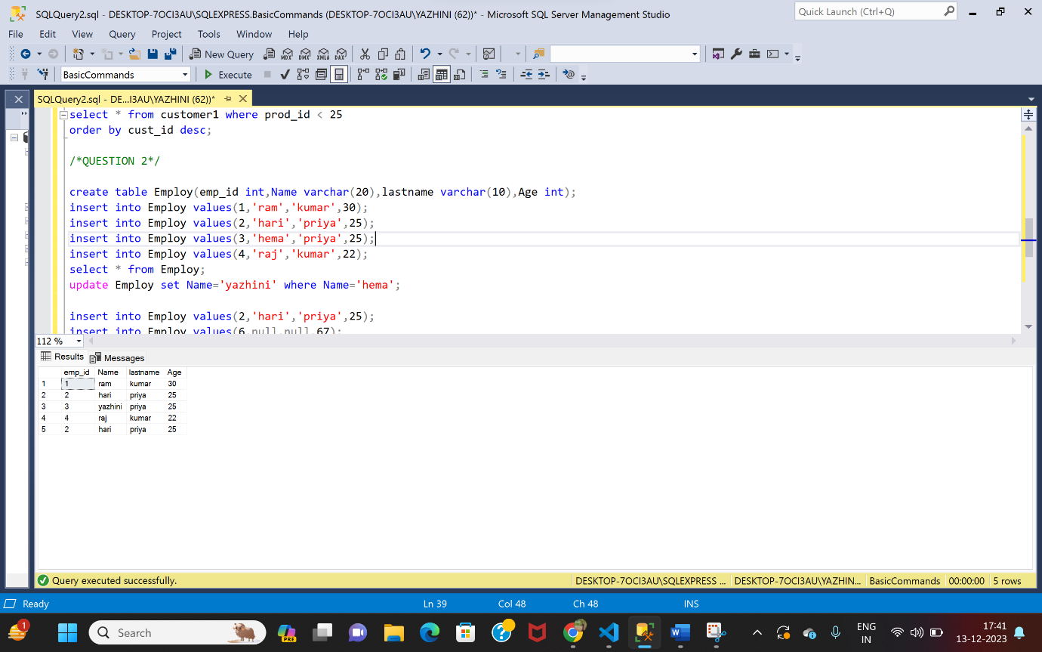

1)GROUPBY,HAVING

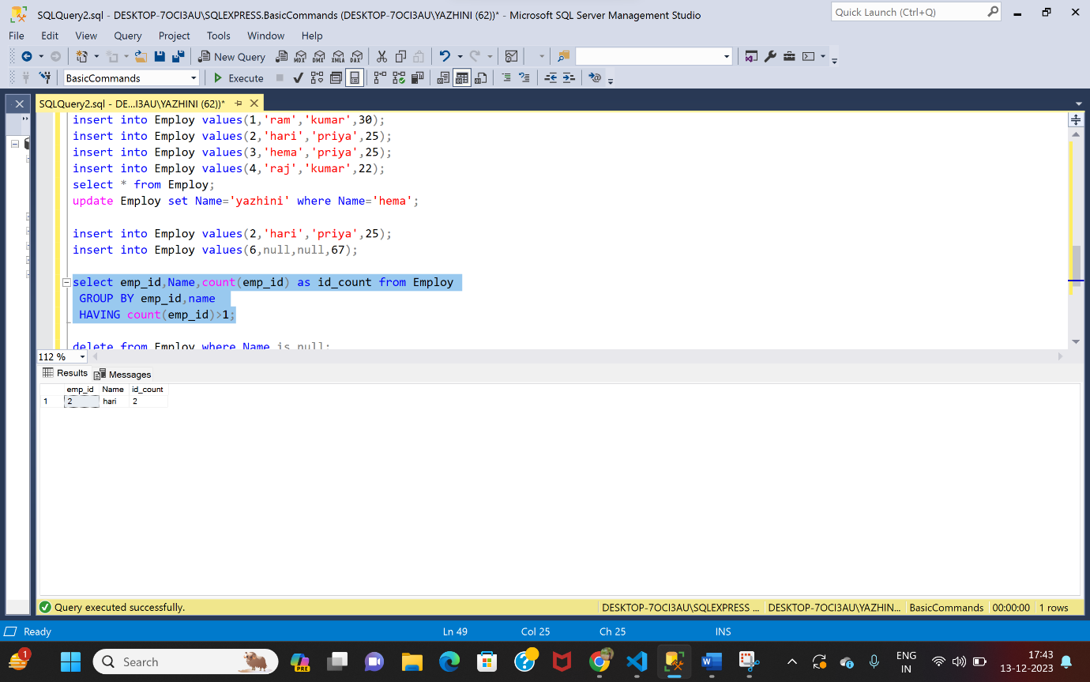

2)UPDATE

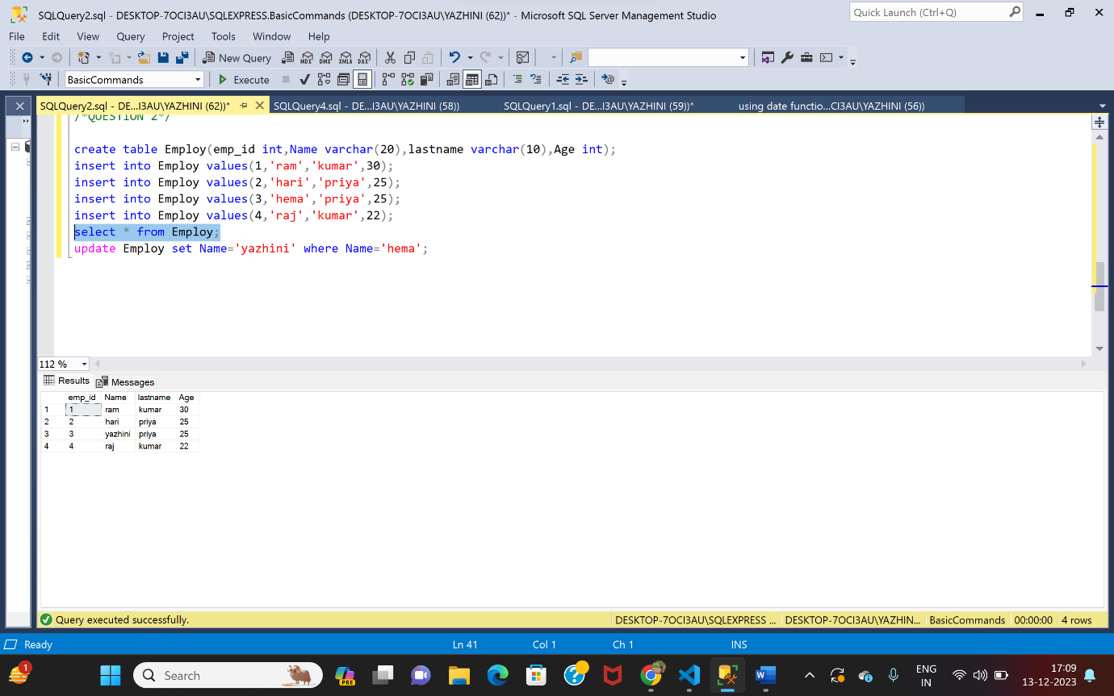

3)DELETE

